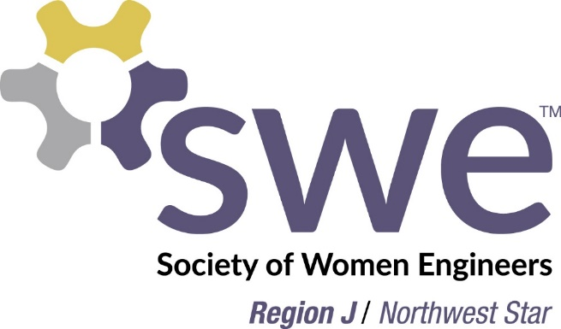

Announcing the FY16
Region J Mentoring Program

Are you a current SWE member with a passion to inspire and develop others in SWE? Do you have a desire to grow your own leadership, coaching, and mentoring skills? If so, the Region J Mentoring Program is for you!
We are looking for SWE members in Region J of ALL experience levels to mentor more junior members in the region. Whether you’re only a couple years in or have been a member of SWE for as long as you remember, there are other SWE members out there who can benefit from your experience and guidance! Please consider being a mentor for Region J!
Mentor resource packets and virtual sessions on various SWE related topics will be provided as part of the program to help set you and your mentee up for success.
The FY16 Region J Mentoring Program launches now! Mentor sign-up runs through 11/30/15. See attached MS Powerpoint file for more program details.
Sign up to be a SWE Region J Mentor here: https://www.surveymonkey.com/r/766SYD5
For any questions please contact the Mentorship Chair, Pratima Rao (pratima.gn.rao@gmail.com).

