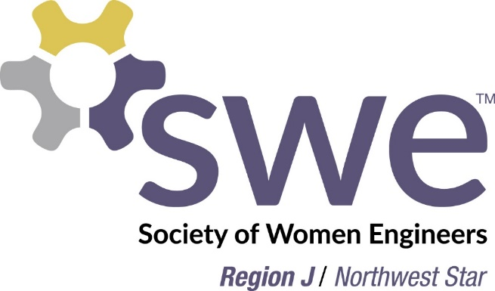
Announcing the FY16
Region J Mentoring Program

Having you been thinking about working with a mentor who can share experiences in professional development and personal choices as well as grow SWE connections?

The SWE Region J Mentoring Program is for you! As part of this program you’ll be paired with a more senior SWE member who can help you build your career and also help you navigate the many benefits of SWE, including award applications, opportunities to be involved, and also networking.

Mentee resource packets and virtual sessions on various SWE related topics will be provided as part of the program to help set you and your mentor up for success.

The FY16 Region J Mentoring Program launches in November! Mentee sign-up runs through 11/30/15. See attached MS Powerpoint file for more program details.

Sign up to be a Region J mentee here: https://www.surveymonkey.com/r/7ZR3Y6Q

For any questions please contact the Mentorship Chair, Pratima Rao (pratima.gn.rao@gmail.com).

